ISIS and the Paris Attacks:

Intro Video #1: How the world reacted to Paris attacks. What words do you think of when watching this video?

DO NOT USE LAPTOPS TO LOOK UP ANSWERS
Question: Do you know what ISIS is? What do you think their main goal is?

ISIS and Paris https://www.youtube.com/watch?v=3bIvqS7gnQo

AFTER ANSWERING THE QUESTIONS THEN WATCH
Video: ISIS and Iraq https://www.youtube.com/watch?v=HJ034SvB16E
- Discussion on ISIS and the Sunni vs. Shiite situation
Video: ISIS and Syria https://www.youtube.com/watch?v=C14Yu0nJCVg

Questions:
- What is life like for those living under ISIS rule? Why are they so controlling?

- How do you propose the threat is dealt with?

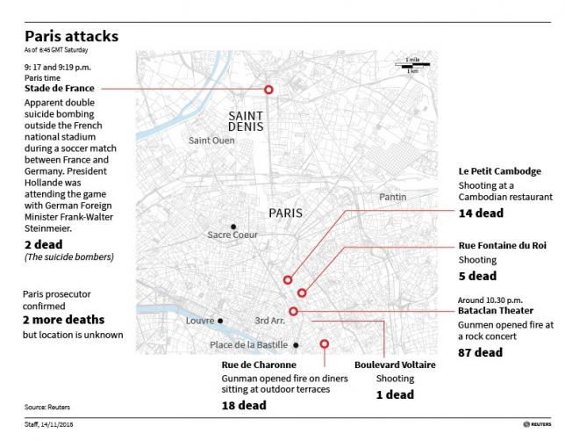
Quotes from the scenes: http://www.huffingtonpost.com/entry/quotes-paris-attacks_5647a95ce4b08cda34891e13

Video: First-hand account of inside concert hall http://www.nytimes.com/video/world/europe/100000004038181/surviving-paris-pulled-from-the-gunfire.html

Follow Up Questions:
- How do you think is it possible that France didn’t know about the attacks?

- Is this a threat that the US should take seriously? Why?

- Should someone be publicly blamed for ISIS attacking Paris?

Video: Islam not to blame http://www.vox.com/2015/11/14/9735806/islam-isis-violent?utm_campaign=vox&utm_content=chorus&utm_medium=social&utm_source=twitter
FOLLOW UP QUESTION: Are there violent Christians? Should we blame all Christians for the acts the violent Christians commit?

Muslims Condemn Violence: http://qz.com/550104/muslims-around-the-world-condemn-terrorism-after-the-paris-attacks/
FOLLOW UP QUESTION: Discuss how eye opening it is that Muslim countries- including those that the US and other Western nations have not gotten along with in the past- now condemn the violence.

Questions:
- Do you know the percent of Islam that ISIS makes up? Without looking up an answer, make a guess based on what you know.

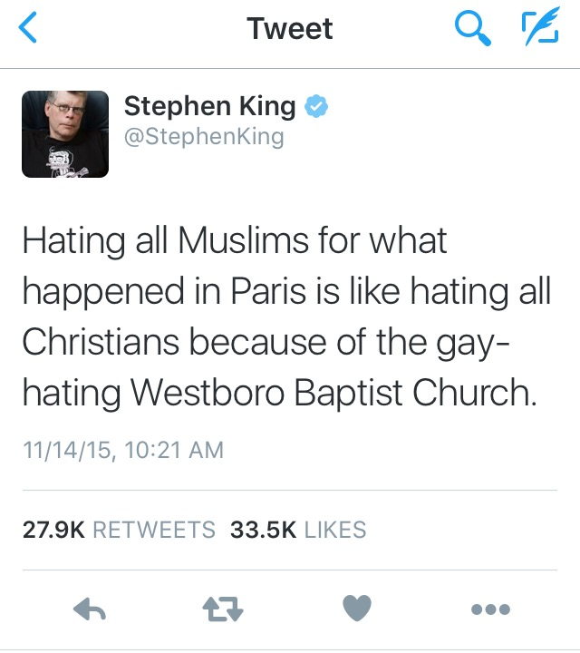
- Does Christianity have extremist groups?

- Should Middle Eastern refugees be allowed to seek refuge in Europe and other countries now?
